Game Development Pipeline Assignment 2 Report

A Rube Goldberg machine is a machine which is designed to perform a very simple task but intentionally made to complete the task in a very overcomplicated way or manner. I decided early on that my machine would be created to pour cereal into a bowl. The reason I went with this decision was that many of the Rube Goldberg machines are created with the intention of serving food so I decided to stick to this concept. Furthermore I felt as though cereal is very easy to represent visually and ending the machine with many small spheres pouring out of a box may be a visually pleasing way to end.

# Machine Breakdown

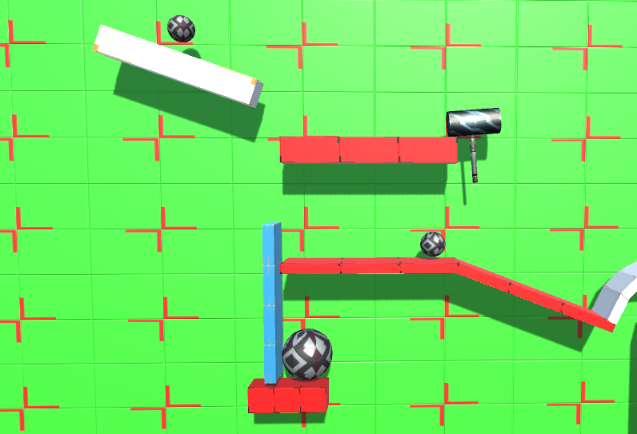The firs element to my machine is the hammer which is placed immediately after the first ramp. The first ball in my sequence rolls down then knocks the hammer over causing it to swing and knock the second ball along its platform. I chose to include this as the first component as whilst it is a very simple component, it is also very visually pleasing and a good way to draw attention to where the viewer should be looking.

The second component to my machine is the blue wall which knocks the larger ball below off its platform once the hammer knocks the smaller ball into it. This was supposed to serve the same purpose of the hammer with being simple and allowing for a ramp up in the components of my machine.

The Third component to my machine is the seesaw which is used to launch the smaller ball on the right up and over the wall into the bucket on the other side. This happens using the force that the larger ball creates when it is knocked off, this kind of component is included in virtually every Rube Goldberg machine so I felt it important to include in mine.

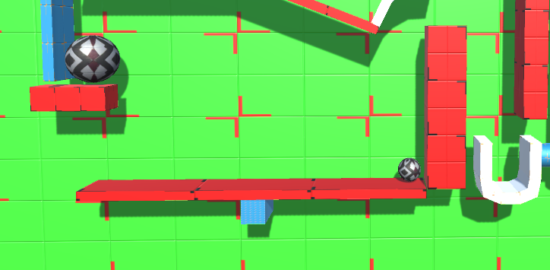

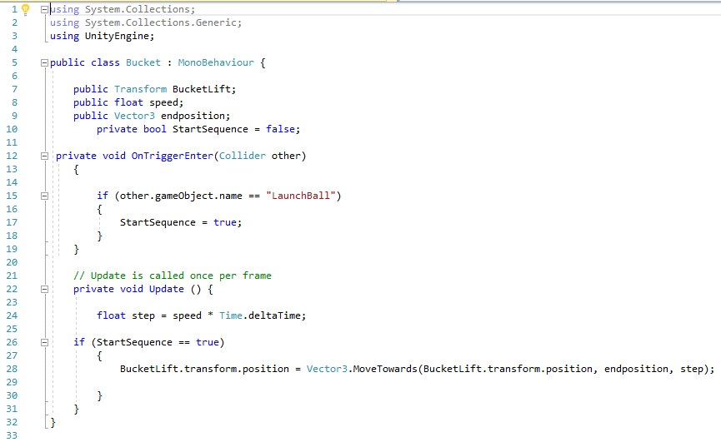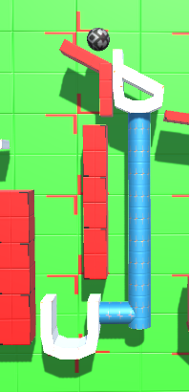The fourth component is the bucket that the ball is launched into, the bucked is connected to a part of the ramp in an adjacent part of the machine. The ball landing into the bucket triggers the whole section to lower, allowing the ball to reach the previously inaccessible area of platform. This is the first part of my machine that uses code rather than just physics, I originally wanted to only use physics in my machine to keep it as true to real life as possible. On the other hand this is a really smooth looking animation and when I came up with the concept I couldn’t think of a suitable replacement.

This is the code that I used which, whilst it is very simple, it is also very effective and looks as if it could be done through just physics.

The fifth component in my machine is the stack of dominos that the ball knocks over after the ramp lowers so the ball can roll past. This is another common feature of Rube Goldberg machines so I wanted to include it in my machine if possible. The final domino pivots around the platform once it is knocked, allowing it to hit the ball waiting underneath the platform.

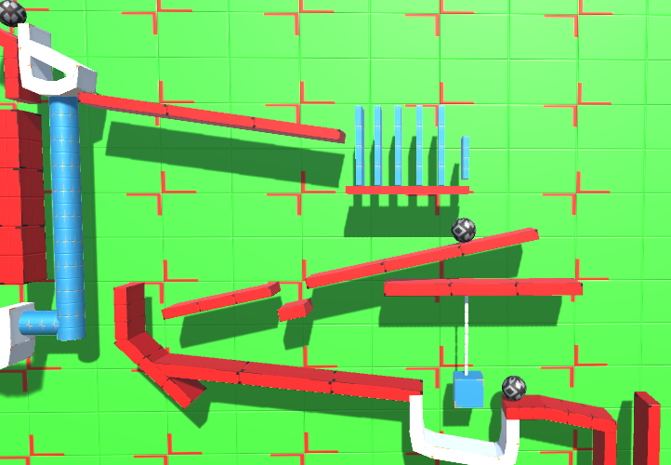The ball that knocks the dominos rolls down in front of them leading onto my sixth component. This ball rolls into the small gap in the platform so that the other ball can roll over the top of it. I included this because it is a very neat way to switch between two balls and also looks very good as the ball rolls down the first domino.

The seventh component is the wrecking ball that is knocked by the ball as it travels down the ramps. This then knocks another ball onto the next part of the machine. I included this as it is a very simple component to create and I used it to learn how to create other parts of the course as it’s a good example of how hinge joints work.

The eighth part of my course is when the ball is knocked off the side by the wrecking ball, it travels down a tube to knock 4 other balls off an edge which is vital for the next component. This component was included to improve visual aesthetics for the next 3 components of my machine.

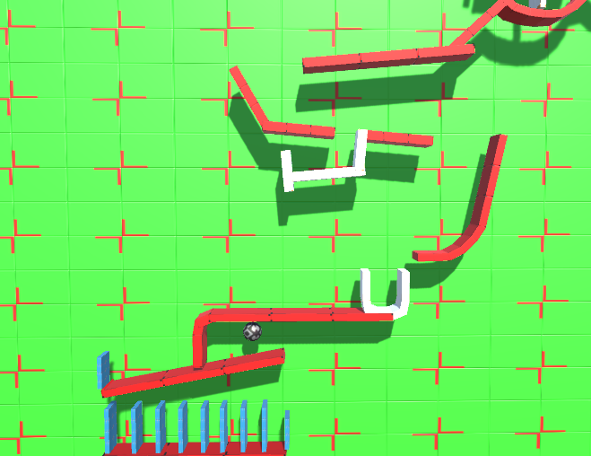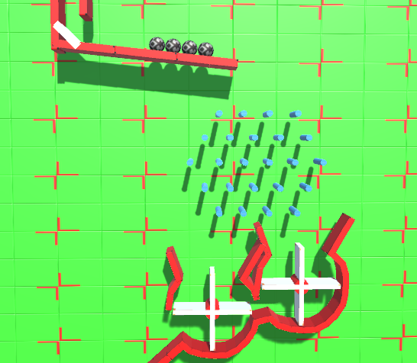The 4 balls and the one that knocked them travel into the ninth component which is a series of pegs. This looks much better with more balls and adds a sense of random chance to the machine which I felt made it much more exciting to view. This also nicely led onto my tenth component which is the two spinners as I wanted the balls separated into two different spinners. The spinners then funnel the balls onto the next component. I didn’t need to include these but that, in my mind, embodies the whole concept of a Rube Goldberg Machine.

The eleventh component for my machine is my way of taking it back to being one ball as that makes it easier to track and I only wanted one ball for the finale. This section under the platform fills with four of the balls and allows the fifth to roll over the top. Reducing the balls was also vital for the seesaw underneath, my twelfth component. As one ball is caught in the cup. This then raises the other side of the platform allowing the ball there to roll free.

The thirteenth component is another set of dominos which I included as they lead up to the final component. I included these for the same reasoning as the other set of dominos, a Rube Goldberg machine normally has a lot of these.

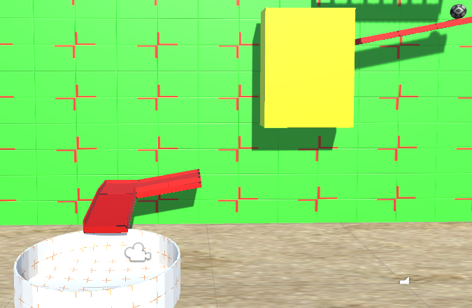My final two components are the box of cereal and the ramp that the cereal travels down. The box of cereal is included for the reasons I mentioned earlier and the ramp is included because I really like the fact that it isn’t needed and I feel like that is what the machine is all about.

# Machine’s strengths and weaknesses

In my opinion the main strength of my machine is how well it flows, I feel like the added time I spent on designing it meant that every part led well onto the other. Furthermore the fact that I used mostly physics means that it looks very realistic, I am very pleased with this effect. The code I used on the bucket at the start also doesn’t look fake enough to ruin this effect.

The one Weakness I feel that the machine has is that maybe the lack of code included doesn’t demonstrate my skills in creating it. The fact that the most complex code is on the bucket and that is simple code may cheapen the time put into the machine.

Overall I feel as though the machine embodies the way a Rube Goldberg machine should be. The skill of the machine is all in the design and the way the machine feels like it could be replicated in real life which I feel makes up for the lack of complexity in the code.